SIMATS ENGINEERING (SAVEETHA SCHOOL OF ENGINEERING)
Department of Computer Science and Engineering
CO3 ASSESSMENT TOOL 2 – Code Review & Repository Evaluation

Course Code: | CSA10 / CSA1063 | Course Title: | Software Engineering
CO Assessed: | CO3 | Assessment: | Assessment Tool 2 – Code Review & Repository Evaluation
Weightage: | 20% | Total Marks: | 25
CO3 Statement: | Build full-stack applications with an emphasis on containerization, version control, and collaborative development
Student Name: | P ROHINI | Reg. No.: | 192524147
Date: | 15-08-2026 | Duration: | 60 minutes

Code of Conduct
IP ROHINI (192524147) (Name / Reg No) certify that this submission is my original work and that I have adhered to the guidelines specified for this assessment. I understand that any violation of academic integrity rules will result in disciplinary action.
Signature of the Student: P ROHINI
Annexure A – Code Review & Repository Evaluation
Instructions to Students:
Each student has been assigned an individual problem statement. Based on the assigned problem statement, perform a Code Review and Repository Evaluation of your project. Analyze the quality of the source code, repository organization, documentation, coding practices, and overall maintainability. Provide appropriate screenshots, code snippets, diagrams, and justifications wherever applicable.

Assignment Questions
- Problem Overview
  - Explain the assigned problem statement and summarize the implemented solution.
  - Describe the project objectives and key functionalities.
- Repository Organization
  - Evaluate the repository structure, folder organization, and file naming conventions.
  - Justify how the repository layout supports maintainability and collaboration.
- Code Quality Review
  - Review the source code for readability, modularity, coding standards, and documentation.
  - Identify strengths and areas for improvement.
- Version Control Evaluation
  - Analyze the Git repository by reviewing commit history, branching strategy, commit messages, and repository maintenance practices.
  - Explain how version control supports collaborative software development.
- Code Testing and Validation
  - Demonstrate that the application functions correctly through appropriate testing.
  - Present test cases, execution results, and screenshots as evidence.
- Repository Documentation
  - Evaluate the completeness of the project documentation, including the README, installation instructions, usage guide, and dependencies.
  - Suggest improvements to enhance usability and maintainability.
- Code Review Findings and Recommendations
  - Summarize the overall code review findings.
  - Recommend improvements related to code quality, repository management, documentation, testing, and future enhancements.

Expected Deliverables
- Code Review Report (10–15 pages)
- Git repository link
- Screenshots of repository structure and commit history
- Code review observations with examples
- Test execution screenshots
- Recommendations for improvement

Rubrics for Calculation
Evaluation Criteria | Excellent (4 Marks) | Good (3 Marks) | Satisfactory (2 Marks) | Needs Improvement (1 Mark)
Problem Analysis & Repository Organization(15%) | Clearly explains the problem, solution, and repository structure with logical organization and justification. | Good explanation with minor omissions. | Basic explanation and repository organization. | Incomplete or poorly organized repository.
Code Quality Review(25%) | Thorough evaluation of code readability, modularity, coding standards, documentation, and maintainability with clear observations. | Good code review with minor gaps. | Basic review with limited analysis. | Superficial or inaccurate code review.
Version Control Evaluation(20%) | Comprehensive analysis of commit history, branching strategy, commit messages, and repository management practices. | Good evaluation with adequate explanation. | Basic evaluation with limited evidence. | Poor or incomplete version control analysis.
Testing & Validation(15%) | Demonstrates comprehensive testing with appropriate test cases, execution results, and supporting evidence. | Good testing with minor omissions. | Basic testing with limited evidence. | Inadequate or missing testing and validation.
Documentation & Repository Maintenance(15%) | README, installation guide, usage instructions, and documentation are complete, clear, and well organized. | Documentation is mostly complete. | Basic documentation with missing details. | Poor or insufficient documentation.
Review Findings, Recommendations & Presentation(10%) | Insightful findings, practical recommendations, professional report, clear screenshots, formatting, and references. | Good recommendations and presentation. | Basic recommendations with acceptable presentation. | Weak conclusions and poor presentation.

Criteria | Mark
System Requirement Analysis (30%) | /5
Selection of Software Architecture (25%) | /5
Architecture Diagram and Component Design (20%) | /5
Component Interaction and Quality Attribute Analysis (15%) | /5
Architectural Justification and Technical Presentation (10%) | /5
TOTAL | /25

CO3-ASSISSMENT TOOL-2

COURSE CODE: CSA1007
COURSE NAME: SOFTWARE ENGINEERING
NAME: P ROHINI
REG NO: 192524147

35) Smart Urban Traffic Congestion Prediction and Signal Optimization Platform
Industry Context
The transportation sector is rapidly adopting digital technologies to improve efficiency, safety, scalability, and decision making. Traditional approaches often rely on manual processes and reactive monitoring, resulting in delays, increased operational costs, resource wastage, and reduced service quality. There is a growing need for an intelligent, cloud-enabled, distributed platform capable of collecting real-time IoT and enterprise data, analyzing operational conditions, predicting risks, and supporting timely interventions.
Problem Statement
Design and develop a distributed Smart Urban Traffic Congestion Prediction and Signal Optimization Platform that continuously acquires real-time operational data from connected devices, enterprise systems, and users. The platform should detect abnormal events, generate predictive insights using AI/ML, notify stakeholders in real time, provide centralized dashboards, generate reports, and support secure, scalable, fault-tolerant operation across multiple locations.

Objectives
• Collect real-time operational data.
• Monitor system performance continuously.
• Detect anomalies automatically.
• Predict failures or risks using analytics.
• Notify stakeholders immediately.
• Generate dashboards and reports.

Code Review & Repository Evaluation
Title
Smart Urban Traffic Congestion Prediction and Signal Optimization Platform
1. Problem Overview
Problem Statement
Urban traffic congestion causes delays, increased fuel consumption, and inefficient use of road infrastructure. Traditional traffic management systems mainly depend on manual monitoring and reactive decisions.
The proposed Smart Urban Traffic Congestion Prediction and Signal Optimization Platform collects real-time traffic data from IoT devices, connected systems, and users. The system analyzes this data to detect abnormal traffic conditions, predict congestion, and support traffic signal optimization.
Implemented Solution
The proposed solution consists of:
- Real-time traffic data collection
- Traffic monitoring
- Congestion prediction
- Signal optimization
- Alert generation
- Dashboard visualization
- Report generation
Objectives
- Collect real-time traffic information.
- Detect abnormal traffic conditions.
- Predict traffic congestion.
- Optimize traffic signals.
- Provide real-time alerts.
- Improve traffic management and decision-making.

2. Repository Organization

Proposed Repository Structure
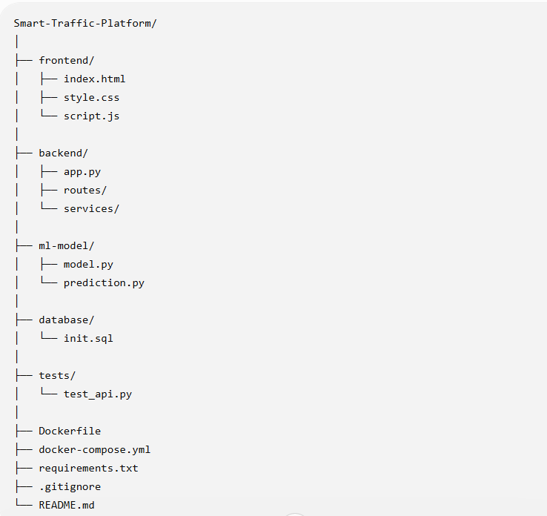
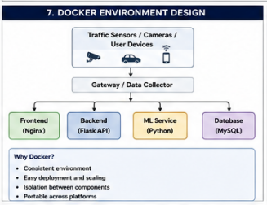
Evaluation
The repository is organized according to functionality. Frontend, backend, ML model, database, and testing files are separated into different folders.
Meaningful file names make the project easier to understand. The modular structure supports maintainability, collaboration, testing, and future development.

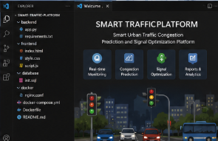
3. Code Quality Review

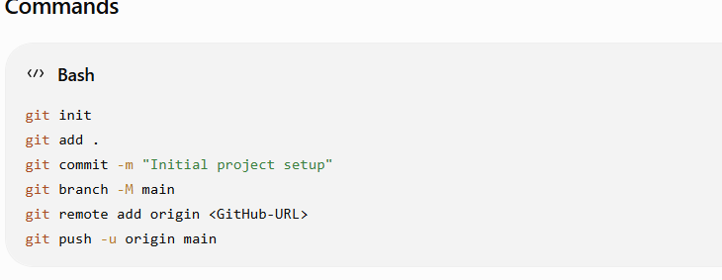
Readability
The source code should use:
- Meaningful variable names.
- Proper indentation.
- Simple and clear functions.
- Comments where necessary.
Modularity
The system is divided into separate components:
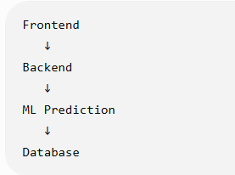
Areas for Improvement
- Add more comments where required.
- Improve error handling.
- Add more automated tests.
- Maintain consistent coding standards.
- Improve API documentation.

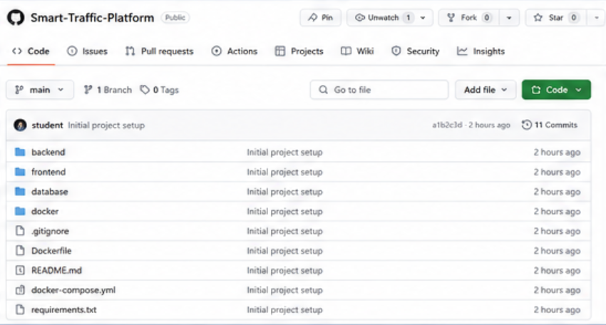

4. Version Control Evaluation
Git is used to manage the project's source code and development history.
Branching Strategy
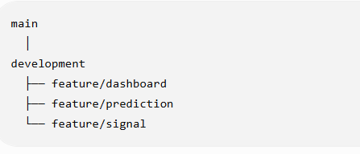
- main – Stable version.
- development – Testing and integration.
- feature – Individual feature development.
This makes development organized and reduces conflicts.
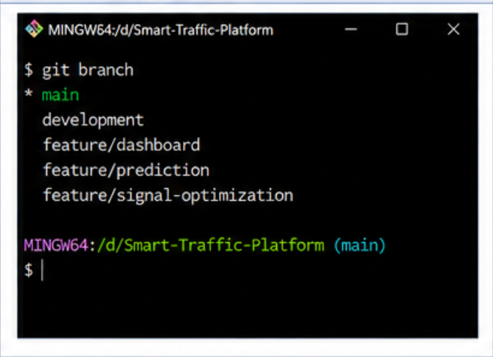
5. Code Testing and Validation
Testing is performed to verify that the application works correctly.

Test Case | Expected Result | Status
Open dashboard | Dashboard loads | Pass
Traffic data request | Data displayed | Pass
Congestion prediction | Prediction displayed | Pass
Signal status | Signal information displayed | Pass
Invalid input | Error handled | Pass
Backend API | API responds correctly | Pass

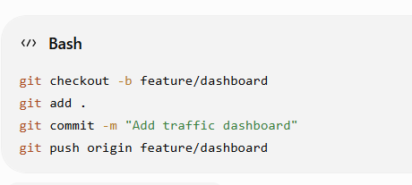
6. Repository Documentation
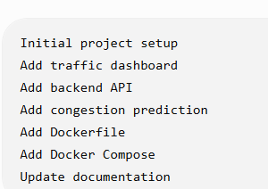
README.md
The README should explain:
- Project title.
- Project objective.
- System features.
- Software requirements.
- Installation steps.
- How to run the application.
- How to test the application.
- Project structure.
Improvements
- Documentation can be improved by:
- Adding screenshots.
- Providing clear installation steps.
- Adding API usage instructions.
- Adding troubleshooting information.
- Keeping documentation updated with code changes.

7. Code Review Findings and Recommendations
Overall Findings
The Smart Traffic Platform has a modular structure suitable for developing a distributed traffic management system. Separating the frontend, backend, ML model, database, and testing components improves organization and maintainability.
Git supports collaborative development, while testing helps validate the system's functionality.
Recommendations
Code Quality
- Follow consistent coding standards.
- Improve error handling.
- Add meaningful comments.
Repository Management
- Use feature branches.
- Use meaningful commit messages.
- Keep unnecessary files out of the repository.
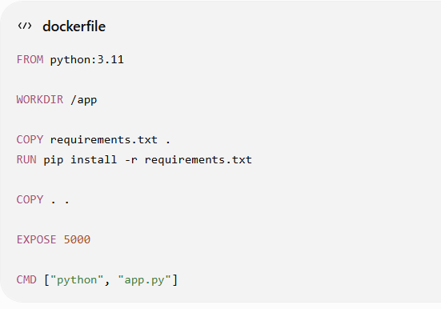
8. Architecture Diagram

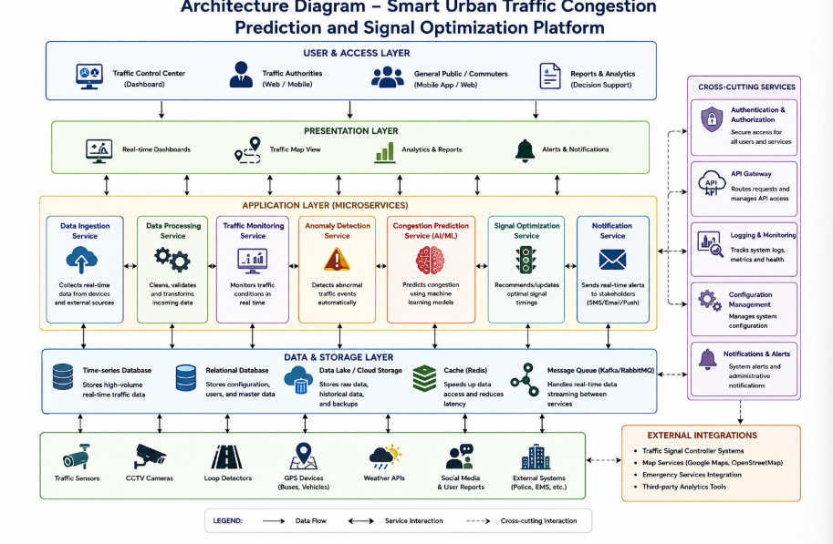

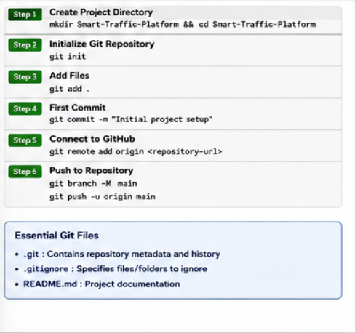
9. Deployment and Testing
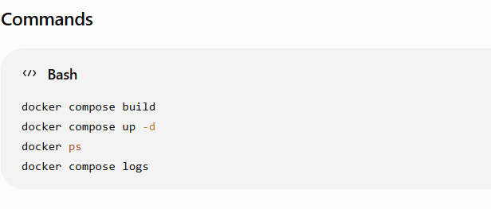

Testing
Check whether:
- Website opens.
- Backend works.
- Database connects.
- Traffic data is displayed.
- Dashboard works.
- Containers communicate correctly.
10. Challenges and Future Improvements
Challenges
- Handling real-time traffic data.
- Managing multiple services.
- Git merge conflicts.
- Docker configuration.
- Supporting multiple locations.
Future Improvements
- IoT integration.
- Advanced AI/ML prediction.
- Automatic signal control.
- Cloud deployment.
- Mobile application.
- Real-time notifications.

Conclusion
The Smart Urban Traffic Platform uses Git for version control and Docker for containerized deployment. The system helps monitor traffic, predict congestion, optimize signals, and support faster decision-making.

